Java

Variables and Datatypes:

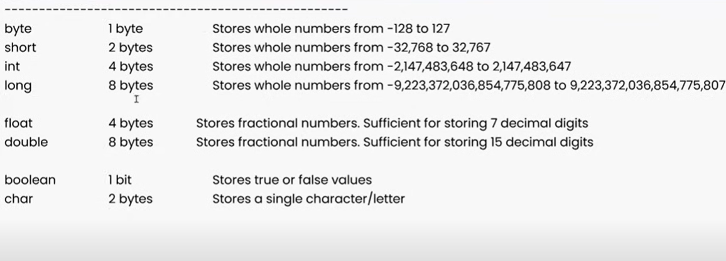

Data types: represent type of data

1) Premitive

byte, short, int, long -> number without decimal

float, double -> decimal number

char -> single character (single quote)

boolean -> true/false

2) Non-premitive/derived/collections

String

ArrayList

HashMap

HashSet

Premitive datatype strores one value at a time.

Non-premitive datatype can store multiple values at a time.

Operators:

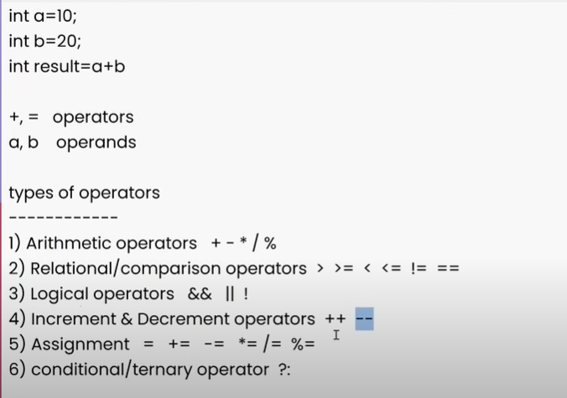

Array:

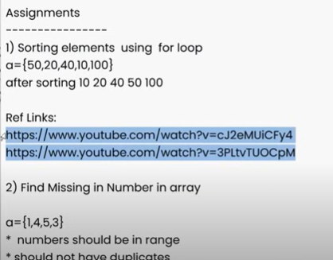

OOPS:

Polymorphism:

One thing can have many forms.

We can achive polymorphism using overloading

Void m1()

Void m1()

Void m1()

4 rules are applicable:

1. Method name should be same.
2. Number of parameters should be different.
3. Data type of parameters should be different
4. Order of parameters should be different.